NAME: -Chinthakindi Sree Vardhan Reddy

SAPID: -500093990

ROLLNO: -R2142210245

BATCH: -2[non-Hons]

Lab Exercise 5– Terraform Variables with Command Line Arguments

Objective: -

Learn how to pass values to Terraform variables using command line arguments.

Prerequisites: -

• Terraform installed on your machine.

• Basic knowledge of Terraform variables.

Steps:

1. Create a Terraform Directory: -



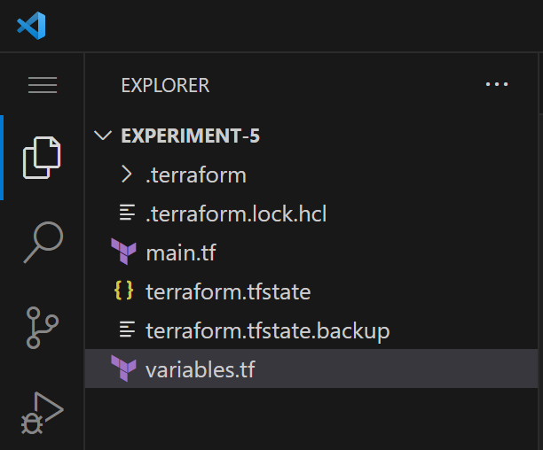

1. Create Terraform Configuration Files: -

• Create a file named main.tf:

# main.tf

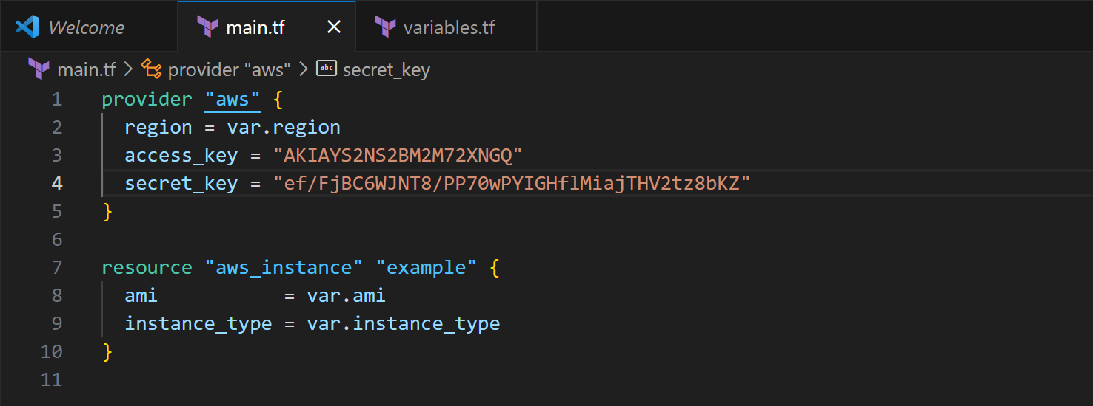

• Create a file named variables.tf:

# variables.tf

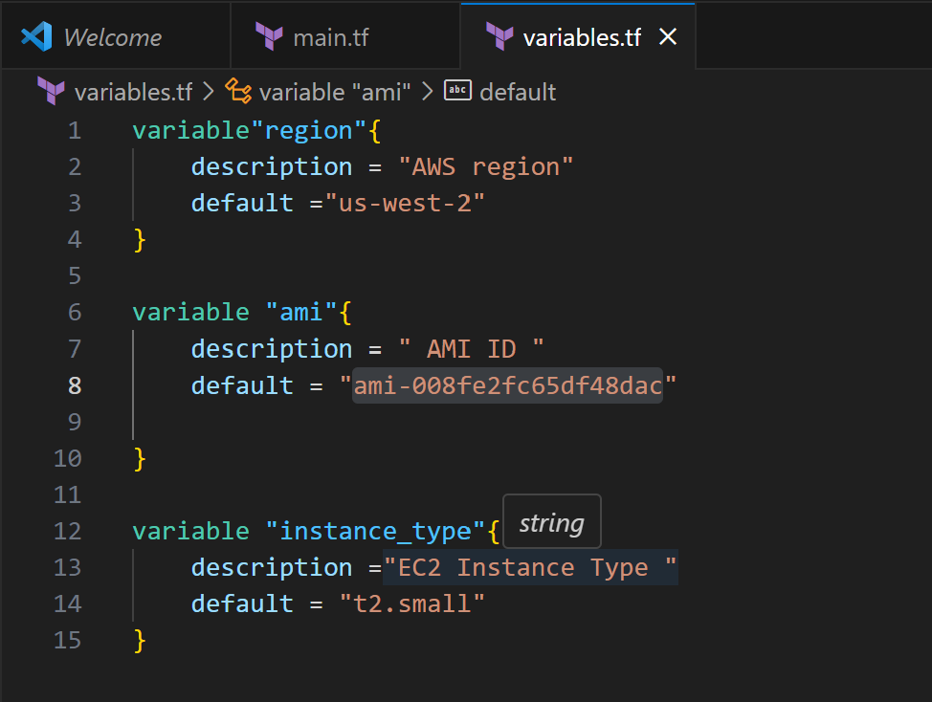

1. Use Command Line Arguments:

• Open a terminal and navigate to your Terraform project directory.

• Run the terraform init command:

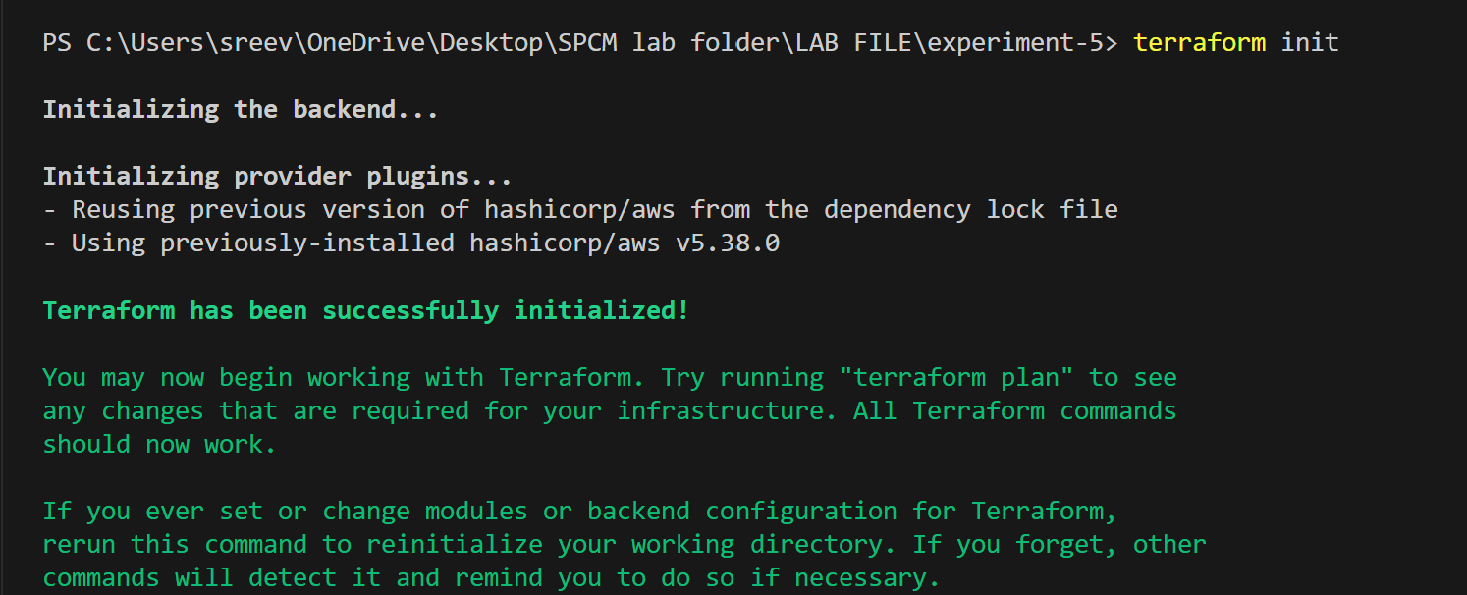

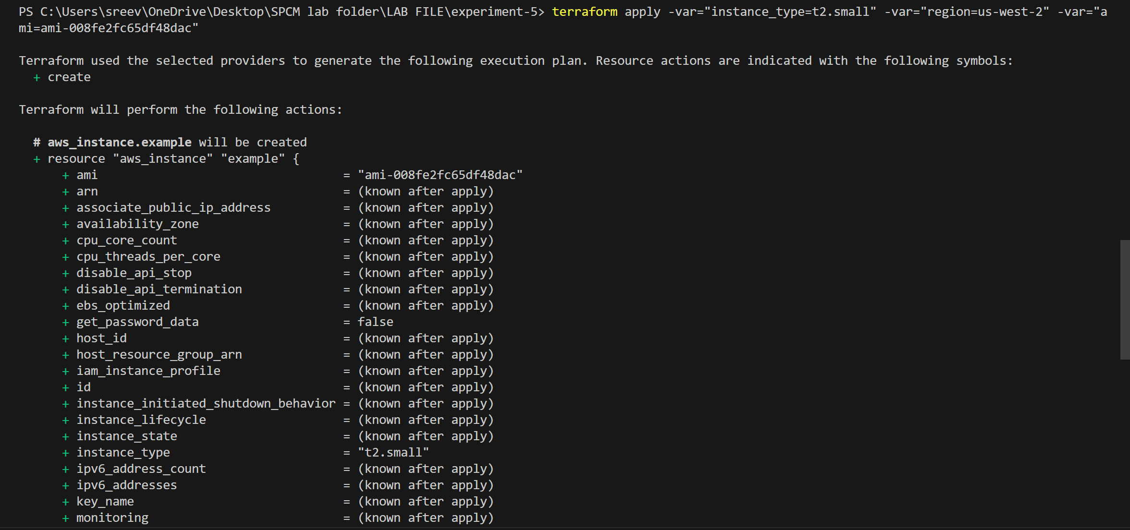

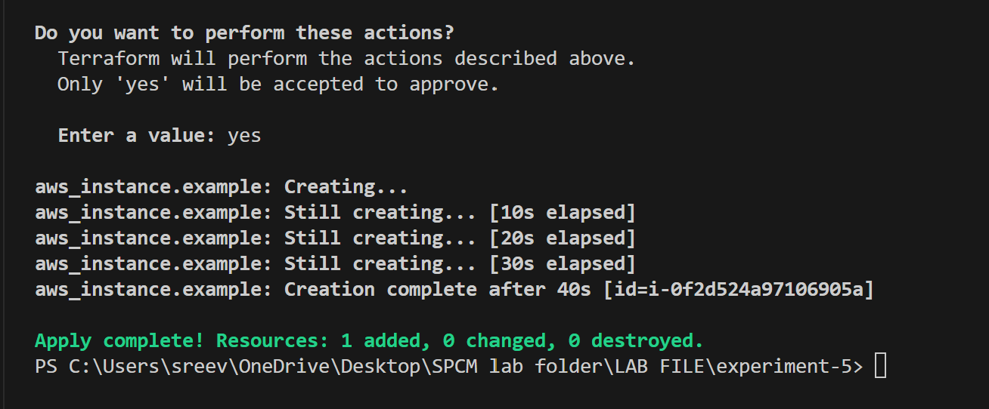

4.Test and Verify:

• Observe how the command line arguments dynamically set the variable values during the apply process.

• Access the AWS Management Console or use the AWS CLI to verify the creation of resources in the specified region.

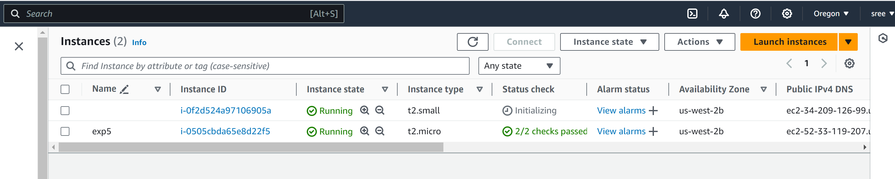

1. Clean Up:

After testing, you can clean up resources:

